**Scripting Language**

**PROJECT WORK: 2024 - 2025**

**DONE BY:**

|  |  |
| --- | --- |
| ELAVARASAN G | (*24509768*) |
| KUMARAN Y | (*24509776*) |
| SANJAY S | (24509781) |
| VAISNAV V M | (*24509788*) |
| MYTHILI  PRIYA DHARSINI V | (24592276)  (24592277) |

Under the guidance of

**U. DEEPIKA BTech.,**

**FACULTY OF COMPUTER ENGINEERING**

Submitted to partial fulfillment of the award of

**DIPLOMA IN COMPUTER ENGINEERING**

Directorate of Technical Education

CHENNAI – 600 025



**DEPARTMENT OF COMPUTER ENGINEERING**

**SAKTHI POLYTECHNIC COLLEGE**

**SAKTHI NAGAR-638 315**

**SAKTHI POLYTECHNIC COLLEGE**

**SAKTHI NAGAR-638315**

**PROJECT WORK: 2024-2025**

**BONAFIDE CERTIFICATE**

**NAME : SEMESTER:**

**REGNO: ROLL NO :**

Certify this is the bona fide record of the project work on **“SCRIPTING LANGUAGE”** done by the 2nd year **DIPLOMA IN COMPUTER ENGINEERING** during the academic year 2024-2025.

**STAFF INCHARGE HEAD OF DEPARTMENT (U. DEEPIKA.Btech.,) (S.S. BOOPATHY M.E.,)**

Submitted for the Practical Examination held on……………………………….

**INTERNAL EXAMINER EXTERNAL EXAMINER**

**ACKNOWLEDGMENT**

We wish to express our first and foremost gratitude to BHATMABHUSAN, ARUTCHELVAR, **DR. N. MAHALINGAM, B.Sc., F.I.E., CHAIRMAN** of Sakthi Polytechnic College, who initiates this institution to provide a basic diploma courses for rural students. We also have to thank him for facilitating the college in the best manner for us to finish our project in a great manner.

We also express our thanks to our **Thiru. M. MANICKAM, M.SC., M.B.A.,** we also thank our correspondent **Thiru.G.muniyasamy.,** for his guidance. chairman

We also express our thanks to our Director **Thiru. Dr. K.R. MUTHUSWAMY** for his guidance.

We also wish to sincerely thank our beloved principal **Thiru. Dr. SENTHIL ARASU., M.E, PHD., MISTE.,** of who gave us a full encouragement to finish our project successfully.

We extend our thanks to our head of department **Mr. SS. BOOPATHY., M.E.,** for his valuable guidance and correction for our project in a best manner.

We wish to express of gratitude and sincere thanks to **Ms.U DEEPIKA.,** **Btech.,** Guidance and timely suggestion, which enabled the successful completion of these.

We also thank all the staff and faulty of our department, and Mr. **MAGUDAPATHI., B.E.,** for their valuable assistance and help to completion of this project would have been a mirage.

**CONTENTS**

|  |  |  |
| --- | --- | --- |
| **S.NO** | **TITLE** | **PAGE NO.** |
| 1. | INTRODUCTION | 1 |
|  | 1.1 ABSTRACT | 5 |
|  | 1.2 PROJECT OBJECTIVE | 5 |
| 2. | SYSTEM ENVIRONMENT | 6 |
|  | 2.1 HARDWARE CONFIGURATION | 6 |
|  | 2.2 SOFTWARE CONFIGURATION | 7 |
|  | 2.3 ABOUT THE SOFTWARE | 7 |
| 3. | SYSTEM DESIGN | 8 |
|  | 3.1 DATABASE DESIGN | 9 |
| 4. | PROJECT OVERVIEW | 10 |
|  | DASHBOARD | 13 |
|  | ADMIN | 14 |
|  | USER | 15 |
| 5 | SYSTEM TESTING AND ENVIRONMENT | 18 |
| 6. | SCOPE OF THE PROJECT | 21 |
| 7. | REFERENCE | 22 |
| 8. | SOURCE CODE | 23 |
| 9. | SCREEN SHOTS | 59 |
| 10. | CONCLUSION | 73 |

**Online Student Managemnt System**

**1.INTRODUCTION**

**ABSTRACT:**

The Online Student Management System (OSMS) is a web-based platform designed to manage the academic, administrative, and financial data of students in educational institutions. This system provides functionalities such as student registration, attendance tracking, course management, grading, and fee payments, which can be accessed by students, teachers, and administrators. By centralizing student information into a single database, OSMS facilitates efficient data management, improving the transparency and accessibility of academic records. The system promotes better communication between students and faculty, ensuring timely notifications and updates. With role-based access control, users can securely access relevant data, minimizing human error and administrative burden. OSMS improves decision-making through data-driven insights and enhances overall institutional efficiency.

**PROJECT OBJECTIVE:**

The **Online Student Management System (OSMS)** is an innovative solution aimed at simplifying and automating the processes involved in managing student information, academic records, and communications within educational institutions. This system provides a comprehensive, efficient, and secure way to manage various aspects of student management, offering both students and administrators a seamless experience.The primary objective of developing the OSMS is to address the challenges that educational institutions face with traditional, manual management systems. It aims to enhance the efficiency, accessibility, and transparency of student data management while minimizing administrative burdens and errors.

One of the key objectives of the OSMS is to simplify the process of managing student data.

**2. SYSTEM ENVIRIONMENT**

**HARDWARE CONFIGURATION:**

This section provides the details and specifications of the **minimum hardware** on which the **“**Online Blood Bank and Donor Management System**”** is expected to run.

* **Processor**: Intel Pentium Dual-Core (or equivalent)
* **Speed**: 1.5 GHz (Minimum)
* **RAM**: 2 GB (Minimum)
* **Hard Disk**: 256 GB (Minimum, preferably SSD for better performance)
* **Keyboard**: Standard Windows Keyboard
* **Mouse**: Optical Mouse
* **Monitor**: TFT Monitor (Resolution: 1280x1024 or higher)

**SOFTWARE CONFIGURATION:**

The **minimum software** required for the development and deployment of the **Scripting Language** is listed below

|  |  |
| --- | --- |
| Operating System - | Windows 10 |
| Front End - | HTML, CSS, JQUERY , JAVA SCRIPT,PHP, |
| Back End -  Server - | MySQL,PHP  XAMPP |
|  |  |

**ABOUT THE SOFTWARE:**

**OVERVIEW OF PHP:**

PHP (Hypertext Preprocessor) is a widely-used open-source server-side scripting language designed for web development. It can also be used as a general-purpose programming language. PHP is embedded within HTML code and is mainly used to interact with databases and manage user sessions in a web application. PHP is easy to integrate with MySQL, making it an ideal choice for developing dynamic websites and applications.

* **Usage**: PHP handles the server-side logic, user authentication, data processing (e.g., domain lookups, SEO reports), and database interactions.
* **Advantages**:
  + Platform-independent
  + Open-source and widely supported

**OVERVIEW OF MYSQL:**

MySQL is an open-source relational database management system (RDBMS) that stores the data required by the platform. It is known for its reliability, scalability, and speed, which makes it a perfect choice for web applications.

Usage in All in One Tools and Utilities Platform: MySQL will be used to store user profiles, historical data of tool analyses, and settings/preferences for users. It will also store metadata related to SEO and domain analysis results, ensuring that each user's data is preserved securely. Structured Data Storage: MySQL organizes data into tables and rows, making it easy to store and retrieve large volumes of structured data.

SQL Support: MySQL uses Structured Query Language (SQL) for querying the database, which is a powerful language for managing and manipulating data. Scalability and Performance: MySQL is optimized for fast data retrieval and can handle a large number of users or requests.ecurity: MySQL provides secure data management with user privileges, encryption, and data protection mechanisms.

**OVERVIEW OF JAVASCRIPT:**

JavaScript is a high-level, dynamic programming language that enables interactivity and rich user interfaces in web applications. It is an essential part of modern web development, especially for client-side programming.

Usage in All In One Tools and Utilities Platform: JavaScript will be used for creating interactive and dynamic user interfaces. For example, the platform's real-time domain lookup and SEO analysis features will use JavaScript to update the content dynamically based on user input without reloading the page.

As a multi-paradigm language, JavaScript supports event-driven, functional, and imperative programming styles. It has application programming interfaces (APIs) for working with text, dates, regular expressions, standard data structures, and the Document Object Model (DOM). However, the language itself does not include any input/output (I/O), such as networking, storage, or graphics facilities, as the host environment (usually a web browser) provides those APIs. Originally used only in web browsers, JavaScript engines are also now embedded in server-side website deployments and non-browser applications.

If you want to explore a map in Google Maps, all you have to do is click and drag with the mouse. You will see the part of the map that is less detailed and then fills itself in. That’s the work of JavaScript behind the scene.

**OVERVIEW OF JQUERY:**

jQuery is a fast and lightweight JavaScript library designed to simplify the process of manipulating HTML elements, handling events, and performing asynchronous requests. It allows developers to write less code and achieve more functionality. jQuery abstracts browser differences, ensuring consistent behavior across all major browsers.

Usage in All In One Tools and Utilities Platform: jQuery will be used to enhance the user experience by enabling smooth AJAX interactions for tools such as domain lookup, SEO analysis, and file conversions. It simplifies event handling and DOM manipulations, making the platform more interactive and responsive.

**OVERVIEW OF BOOTSTRAP:**

**Bootstrap** is a free, open-source front-end framework used to design and build responsive and mobile-first websites and web applications. It was originally created by Twitter developers Mark Otto and Jacob Thornton in 2011. The goal of Bootstrap is to provide a set of tools that streamline web development, allowing developers to create websites that look great and function well across all devices and screen sizes.

**KEY FEATURES OF BOOTSTRAP:**

1. **Responsive Grid System:** Bootstrap’s grid system allows developers to create flexible and responsive layouts. The grid is based on a 12-column system, which makes it easier to arrange content on different screen sizes, from mobile phones to large desktops.
2. **Pre-built CSS Components:** Bootstrap comes with a variety of pre-designed, reusable components such as buttons, forms, navigation bars, modals, cards, and more. These components help developers save time and create consistent, visually appealing designs.
3. **Customizable Themes:** While Bootstrap provides a default theme, it is highly customizable. Developers can modify its appearance by overriding the default CSS or by using Bootstrap’s built-in themes and variables.
4. **JavaScript Plugins:** Bootstrap includes a set of built-in JavaScript plugins for adding interactive features, such as carousels, modals, tooltips, popovers, and more. These features enhance the user experience on the site.
5. **Cross-browser Compatibility:** Bootstrap ensures that websites built with it are compatible with major browsers like Chrome, Firefox, Safari, and Internet Explorer, reducing the need for extensive browser-specific adjustments.
6. **Mobile-first Design:** Bootstrap is built with a mobile-first approach, meaning it is optimized for mobile devices by default. As a result, web pages built using Bootstrap automatically adjust to different screen sizes and resolutions.
7. **Easy to Use:** Bootstrap is user-friendly and comes with extensive documentation, making it accessible to both beginner and experienced web developers. It simplifies the process of web development and allows for faster deployment.

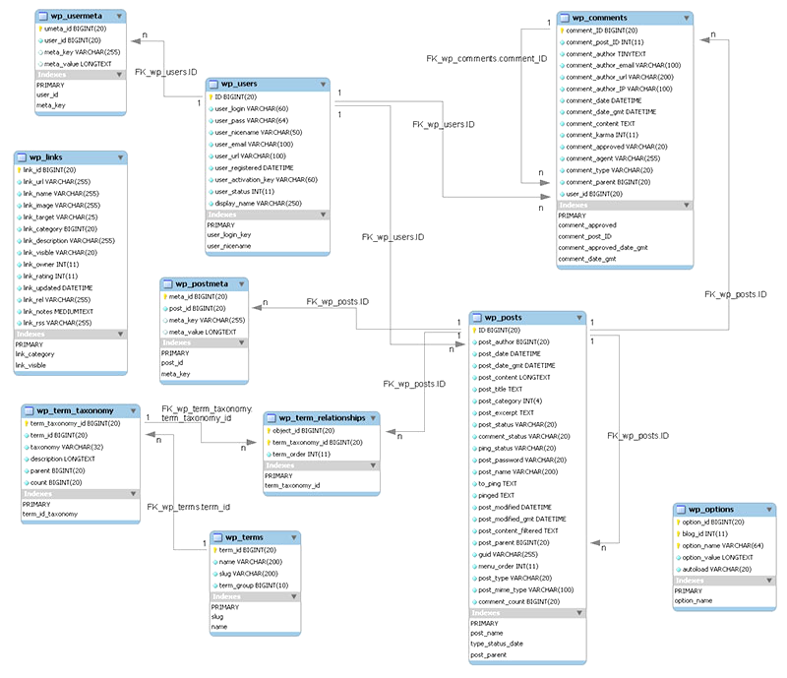**4.1 DATABASE DESIGN**

**3.PROJECT OVERVIEW**

**DASHBOARD**

The **Administrator Dashboard** in your **Student Attendance System** provides a central control panel for managing different aspects of the school environment.

#### ****Dashboard Overview****

* Displays summarized statistics of the school system.
* Provides quick access to essential modules.
* Shows real-time data related to students, teachers, classes, and attendance.

#### ****2. Key Dashboard Metrics****

* **Students:** Displays the total number of students in the system (31 in this case).
* **Classes:** Indicates the number of registered classes (3).
* **Class Arms:** Represents subdivisions within classes (4).
* **Total Student Attendance:** Shows the attendance count (15).
* **Class Teachers:** Number of class teachers in the system (3).
* **Sessions & Terms:** Provides an overview of the academic sessions (2) and terms (3).

#### ****3. Sidebar Menu (Left Panel)****

The sidebar contains options for managing different modules:

* **Manage Classes:** Allows the admin to create, edit, and assign students to different classes.
* **Manage Class Arms:** Helps in organizing students into different sections or arms within a class.
* **Manage Teachers:** Used to add, update, or remove class teachers.
* **Manage Students:** Enables student enrollment and modification of student records.
* **Manage Sessions & Terms:** Admin can define academic years and terms for structuring the school calendar.

#### ****4. User Profile & Navigation (Top Right Corner)****

* The **"Welcome Admin"** section indicates that the logged-in user is an administrator.
* **Search Bar:** Allows quick navigation across the system.
* **Settings & Icons Panel:** Provides access to various administrative settings, notifications, and user options.

### ****Purpose & Importance****

This dashboard serves as a **control center** for the administrator, ensuring smooth management of school data, attendance tracking, and academic structure. The structured layout enhances usability and efficiency for school management.

**ADMIN**

The **Administrator** plays a crucial role in managing and overseeing the **Student Attendance System**. This user has the highest level of access and is responsible for ensuring the smooth operation of the system.

### ****1. Role of the Administrator****

The **Admin** is the **superuser** of the system, responsible for managing students, teachers, attendance records, and system configurations. The admin ensures that the system runs efficiently and that data is accurate and up to date.

### ****2. Responsibilities of the Administrator****

#### ****A. User Management****

* **Manage Students** – Add, update, or delete student records. Assign students to specific classes and class arms.
* **Manage Teachers** – Register and assign teachers to different classes. Update teacher details when necessary.
* **Manage Admin Users** – Add or remove other admin accounts if multiple administrators are required.

#### ****B. Class & Academic Management****

* **Manage Classes & Class Arms** – Create and structure classes into different arms to organize students effectively.
* **Manage Sessions & Terms** – Define academic sessions (e.g., 2024/2025) and set up terms (e.g., 1st, 2nd, and 3rd terms).

#### ****C. Attendance Monitoring****

* **View and Track Student Attendance** – Monitor student attendance records in real-time.
* **Generate Reports** – Create attendance reports for students and teachers for administrative and academic evaluation.

#### ****D. System Configuration & Settings****

* **Dashboard Customization** – Configure system preferences, update school details, and manage notifications.
* **Data Backup & Security** – Ensure regular backups and maintain security protocols to protect student and teacher records.

### ****Importance of the Administrator****

* Ensures smooth operation of the **Student Attendance System**.
* Maintains **accurate and up-to-date** records of students, teachers, and attendance.
* Provides **security and access control**, ensuring that only authorized users can modify the system.
* Facilitates **efficient school management**, reducing manual errors and saving time.

**USERS**

Apart from the **Administrator**, there are two main types of users in the **Student Attendance System**:

1. **Teachers**
2. **Admin**

## **Teacher Role in the System**

### ****A. Responsibilities of a Teacher****

The **Teacher** is responsible for managing student attendance, class activities, and academic performance. Their key duties include:

* **Taking Attendance:** Marking students present or absent daily.
* **Managing Class Records:** Updating student details and monitoring attendance trends.
* **Viewing and Updating Attendance Reports:** Checking attendance summaries and making necessary adjustments.
* **Managing Subjects and Assignments:** Assigning homework or classwork (if included in the system).
* **Interacting with Students:** Sending important notifications or messages regarding attendance or class schedules.

### ****B. Features Available to a Teacher****

* **Dashboard Access:** View assigned classes, students, and attendance statistics.
* **Attendance Management:** Mark, update, and review attendance records.
* **Student List Management:** View student details and academic information.
* **Reports & Analytics:** Generate reports on student attendance and performance.
* **Session & Term Tracking:** Follow school academic sessions and adjust teaching schedules accordingly.

### ****C. Importance of the Teacher in the System****

* Ensures **accurate attendance tracking** for students.
* Helps maintain **structured and updated class records**.
* Provides **feedback on student attendance trends** to the admin and parents.
* Reduces manual work through **automated attendance reporting**.

## **Administrator Role in the System**

### ****A. Responsibilities of an Admin****

The **Administrator (Admin)** has the highest level of access in the system. Their key responsibilities include:

* **User Management:** Adding, editing, and deleting teachers and students from the system.
* **Class & Subject Management:** Assigning subjects, teachers, and students to their respective classes.
* **Attendance Monitoring:** Overseeing student attendance records and generating reports.
* **System Configuration:** Setting up academic sessions, school terms, and attendance rules.
* **Dashboard Management:** Viewing system-wide statistics, including student numbers, attendance trends, and teacher activities.
* **Generating Reports:** Creating detailed reports on attendance, teacher performance, and student participation.

### ****B. Features Available to an Admin****

* **Full Dashboard Control:** View system analytics, number of students, teachers, and attendance reports.
* **Manage Classes & Users:** Assign teachers to classes, enroll students, and manage user access.
* **Attendance Review:** Oversee attendance entries made by teachers and make corrections if needed.
* **Session & Term Management:** Define academic terms and adjust schedules accordingly.
* **Reports & Analytics:** Generate attendance, performance, and user activity reports.

### ****C. Importance of the Admin Role****

* Ensures **system security and proper user access control**.
* Helps maintain an **organized school structure** through efficient class and subject management.
* Provides **valuable data insights** through attendance analytics and reports.
* Reduces errors by **overseeing and correcting attendance records**.

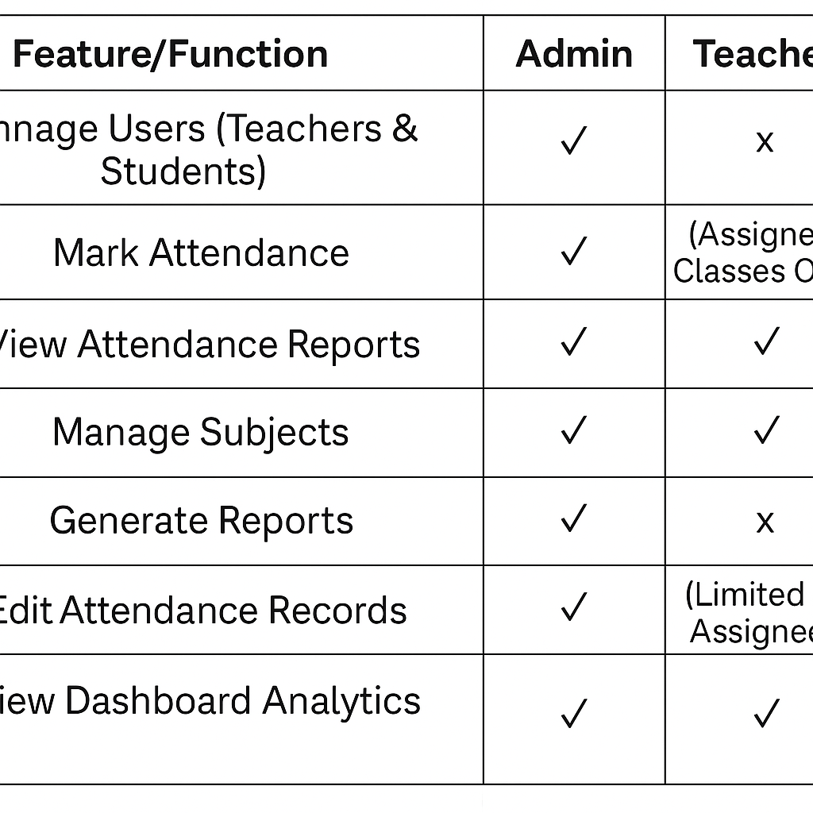

**5. SYSTEM TESTING AND ENVIRONMENT**

**SYSTEM TESTING:**

System testing is an essential phase of the software development life cycle, aimed at ensuring the system meets its specified requirements and functions correctly across all components. The goal of system testing is to identify and eliminate errors by validating whether the software behaves as expected. The process involves executing various types of tests on individual components, integrations, and the entire system to identify potential issues, performance bottlenecks, or discrepancies between user expectations and system behavior.

**TYPES OF TESTING**:

Testing types address specific objectives, ensuring the reliability, functionality, and overall performance of the "XAMPP" platform

**UNIT TESTING:**

Unit testing involves testing individual units or components of the system. Each function or method is tested in isolation to ensure it produces the correct output for a given input.

**SYSTEM TESTING:**

System testing ensures the entire platform functions as a complete, integrated solution. It involves testing the system as a whole to verify that it meets its business, technical, and user requirements.

**WHITE BOX TESTING:**

White box testing involves testing the internal logic of the system. This type of testing requires knowledge of the code and its structure. It checks the internal workings, such as algorithm logic, data flow, and control flow, for tools like SEO analysis and domain lookup. Check for proper branching and data flow handling in functions. The testing strategy focuses on both manual and automated testing for different tools and modules. The primary objective is to ensure the platform is functionally user friendly

**6. SCOPE OF THE PROJECT**

The Online Student Management System (OSMS) is designed to improve the overall efficiency, transparency, and organization of student data management in educational institutions. The scope of this project defines the functionalities, limitations, and boundaries of the system, ensuring that the system meets the institution’s administrative, academic, and financial needs while addressing the core objectives of automation and digitalization. The scope of this project encompasses several key areas, including user roles, functionalities, technological infrastructure, and integration with existing systems.

The **OSMS** will consist of several modules, each catering to specific management needs within the institution.

Faculty members can input, update, and manage student grades for assignments, exams, and coursework.

Students can access their academic performance and grades through the system.

Generation of report cards and transcripts for individual students.

Communication tools for students and faculty to interact, such as direct messaging, announcements, and forum discussions.

Automated notifications for class schedules, exam dates, grade updates, fee payment reminders, and other important institutional announcements.

**7.REFERENCE**

**ON-LINE REFERENCES**

**1.**<https://www.geeksforgeeks.org/>

**2.**<https://www.w3schools.com/>

**3.**<https://www.tutorialspoint.com/>

**4.**<https://www.digitalocean.com/>